# Symbols not rotating

# 

### This… Should be this

## Check for:

### Numeric Value in SymbolRotation field

### 

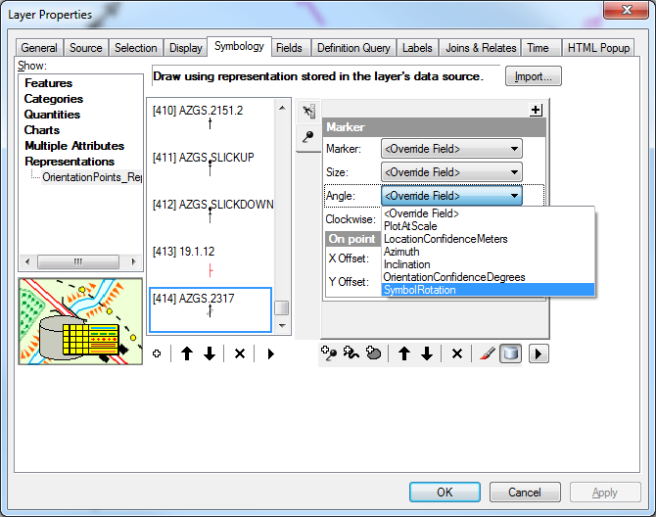

## Check for:

### 2. That the SymbolRotation field is selected for that symbol on the Layer Properties Symbology Tab